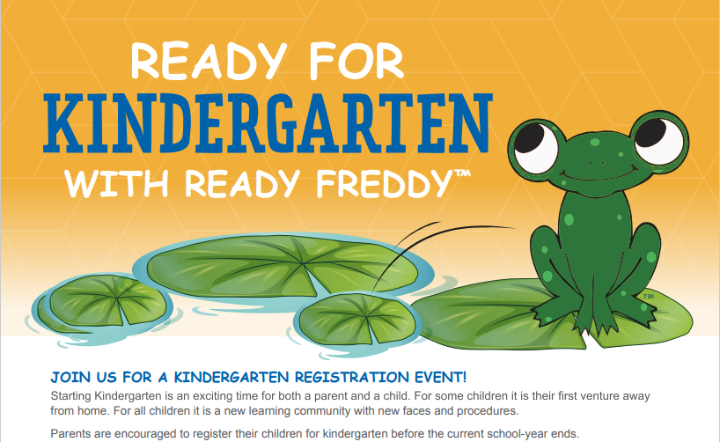

We would like to welcome you to Clark Elementary as you begin the journey of your child starting Kindergarten. Please join us for a virtual informational session about Clark Elementary.

**School:** Clark Elementary

**Date:** 02/19/25

**Location:** Clark Elementary

**Time:** 5:00-6:00

**How to Register:** Use the link below to register. A link will be sent for the virtual meeting once registration occurs.

**Use QR code or Link to Register:**

<https://www.signupgenius.com/go/10C0C4AAFA82EA5F9CE9-47551240-kindergarten>

